Non-Governmental Organizations Approved List

Logo | Non Governmental Organizations | Local/ International | Website
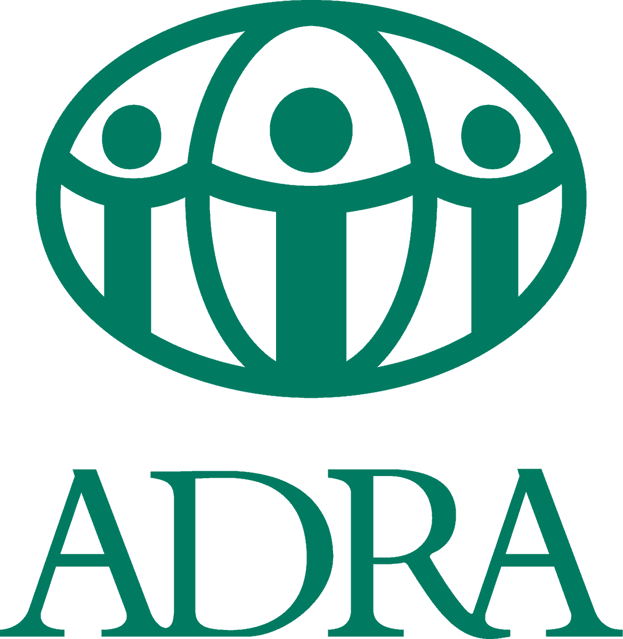 | ADRA Bahamas | Local | https://www.adra.bs/
 | Ali McIntosh Children’s Charity | Local | https://www.facebook.com/AliMcintoshChildrenCharities/
 | Ambassador Choral International Association | Local
 | Assemblies of Brethren in The Bahamas | Local | https://www.facebook.com/Assemblies-of-Brethren-in-The-Bahamas-840067239356163/
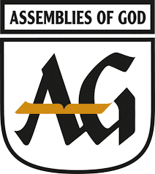 | Assemblies of God Bahamas | Local | http://www.agbahamas.com/
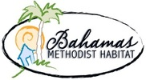 | Bahamas Methodist Habitat | Local | https://www.methodisthabitat.org/
 | Bahamas Association for Social Health (BASH) | Local | https://www.facebook.com/Recovery242/
 | Bahamas Chamber of Commerce and Employers’ Confederation (BCCEC) | Local | https://www.thebahamaschamber.com/
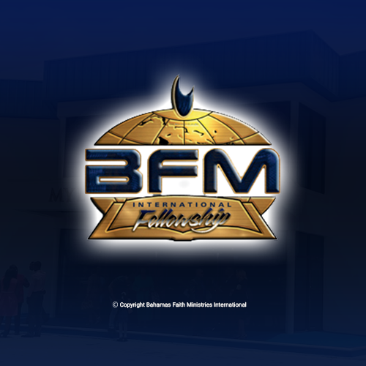 | Bahamas Faith Ministries International | Local | https://www.bahamasfaithministries.org/
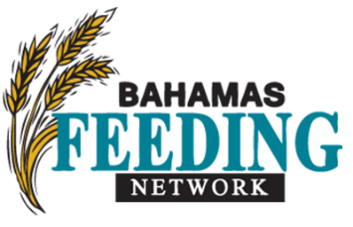 | Bahamas Feeding Network (BFN) | Local | https://www.bahamasfeedingnetwork.org/
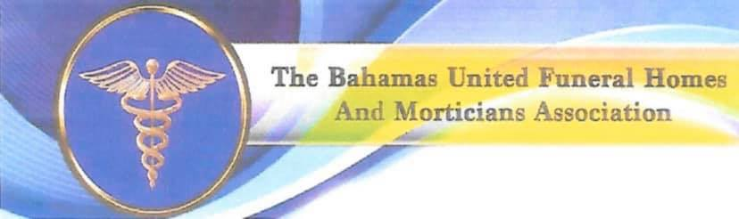 | Bahamas Funeral Directors Association | Local | https://www.facebook.com/bfda242/
 | Bahamas Genesis Life Center
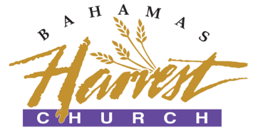 | Bahamas Harvest | Local | https://bahamasharvestchurch.org/
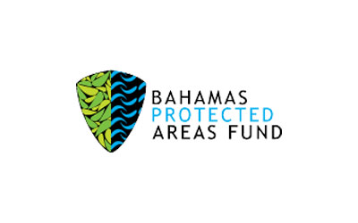 | Bahamas Protected Areas Fund | Local | https://bahamasprotected.com/
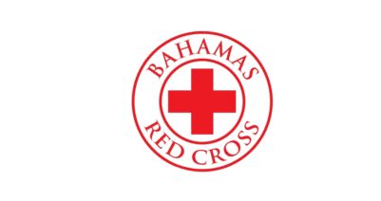 | Bahamas Red Cross | Local | https://bahamasredcross.org/
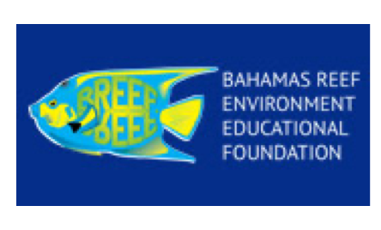 | Bahamas Reef Environment Educational Foundation (BREEF) | Local | https://breef.org/
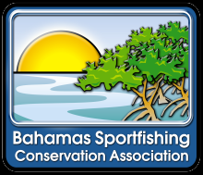 | Bahamas Sportfishing & Conservation Association | Local | http://bahamasconservation.org/
 | Bahamas Urban Youth Development Center | Local | https://www.facebook.com/BUYDC242/
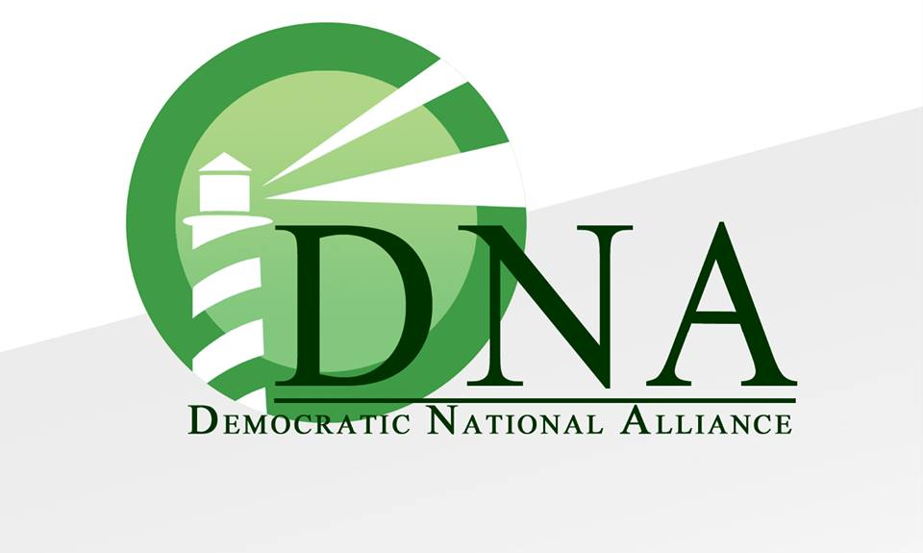 | Democratic National Alliance | Local | https://www.mydnaparty.org/
 | F.O.A.M | Local | https://www.facebook.com/F.O.A.MCOMMUNITY/?ref=page_internal
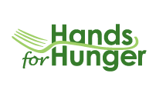 | Hands for Hunger | Local | https://handsforhunger.org/
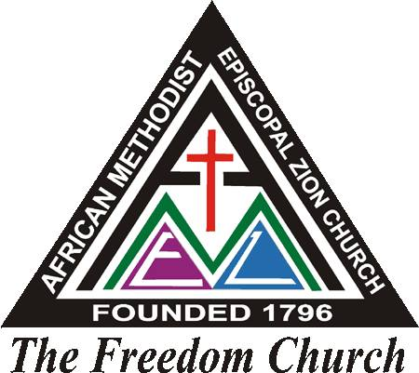 | Holy Trinity AME Zion Church | Local | https://www.facebook.com/Holy-Trinity-AME-Zion-Church-Nassau-Bahamas-175781936384683/
 | Human Rights Bahamas | Local | https://www.facebook.com/HRB242/
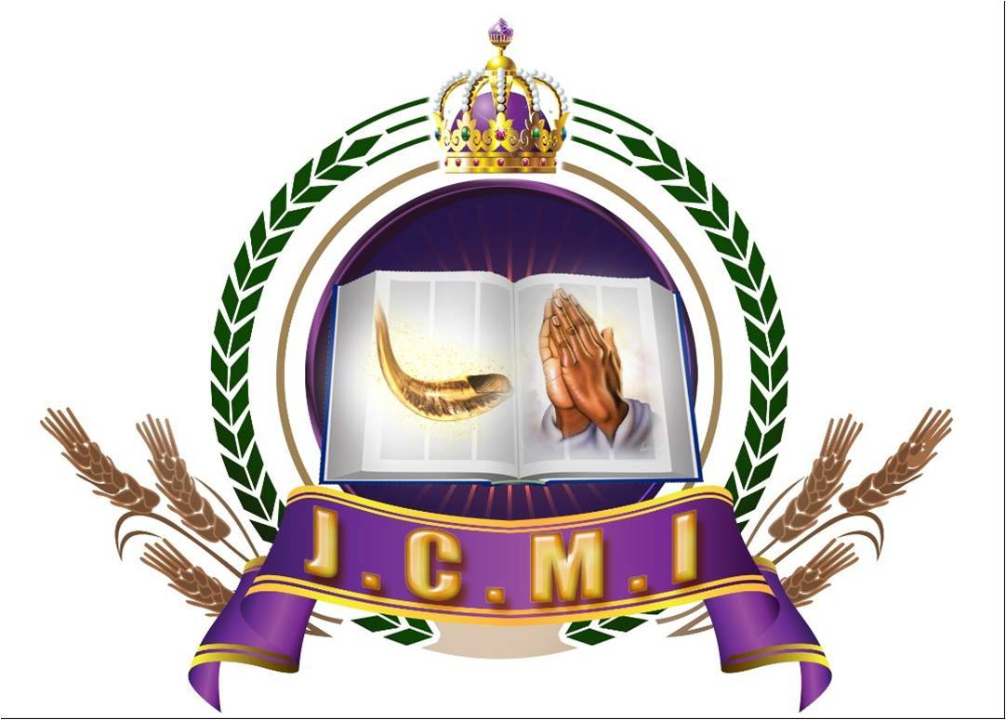 | Jubilee Christian Ministries International | Local | https://www.facebook.com/JCMInternational/
 | Kiwanis Clubs of The Bahamas | Local | https://www.kiwanisnassaudivision.com/
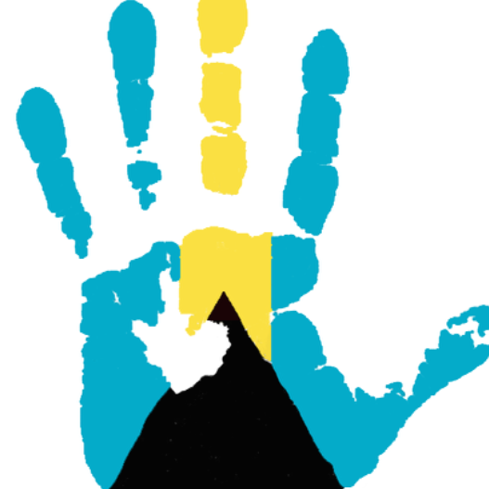 | Lend A Hand Bahamas | Local | https://www.lendahandbahamas.org/
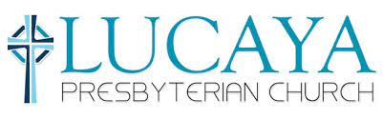 | Lucaya Presbyterian Church Cross Reach | Local | https://www.lucayachurch.com/
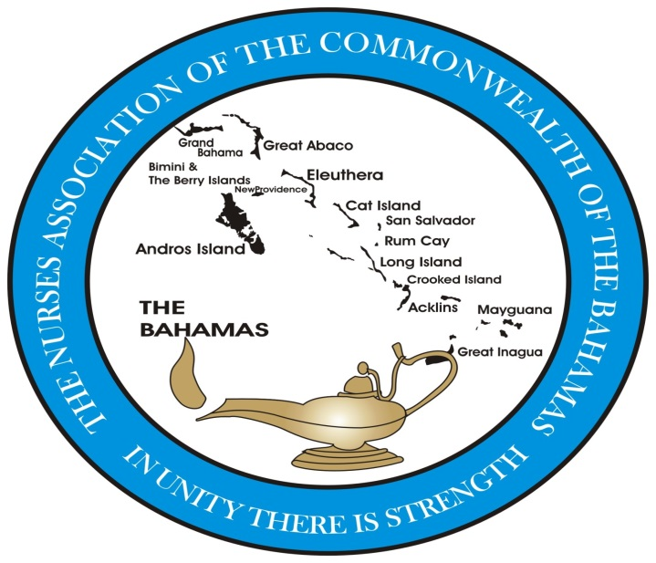 | Nurses Association of the Commonwealth of the Bahamas | Local | https://nacb242.com/
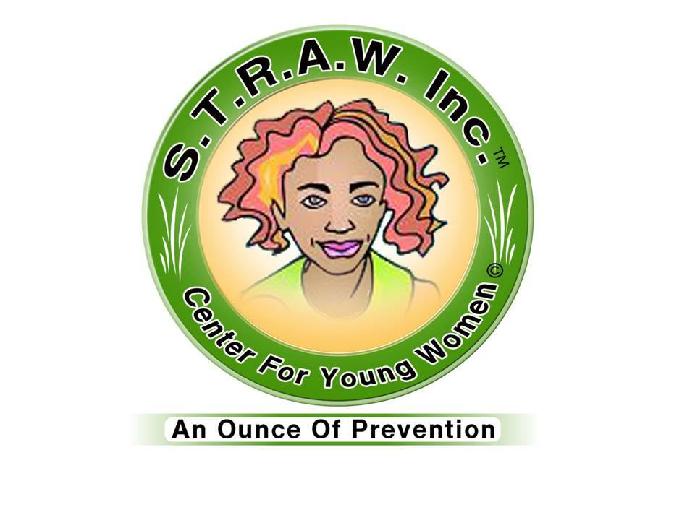 | S.T.R.A.W Inc. Center for Young Women | Local | https://www.facebook.com/STRAW-Inc-Center-for-Young-Women-49234557251/
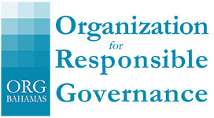 | Organization for responsible Governance | Local | https://www.orgbahamas.com/
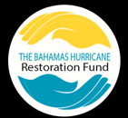 | Restore Bahamas | Local | http://thebahamashurricanerestorationfund.org/
 | Street Legends Organization | Local | https://www.facebook.com/The-Street-Legends-Organization-1718465644901136/?ref=page_internal
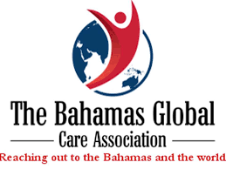 | The Bahamas Global Care Association | Local | https://www.facebook.com/The-Bahamas-Global-Care-Association-377904896318871/
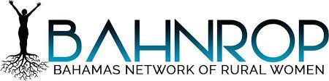 | The Bahamas Network of Rural Women Producers | Local | https://www.facebook.com/BAHNROP/
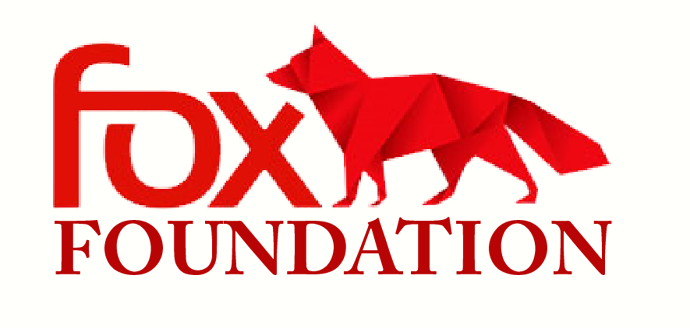 | The Fox Foundation | Local | https://www.facebook.com/thefoxfoundation/
 | The Indaba Project | Local | https://www.facebook.com/The-Indaba-Project-275796057940/
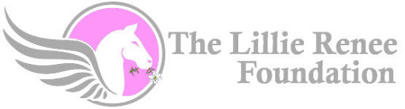 | The Lillie Renee Foundation | Local | http://www.lilliereneefoundation.com/
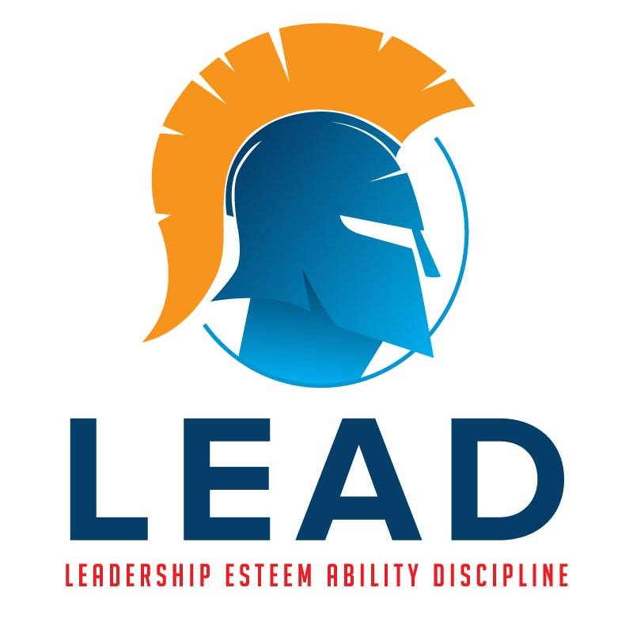 | The National Leadership Esteemed Ability Discipline (L.E.A.D) Institute | Local | https://www.facebook.com/CommunityCorrectonalTraining/?ref=page_internal
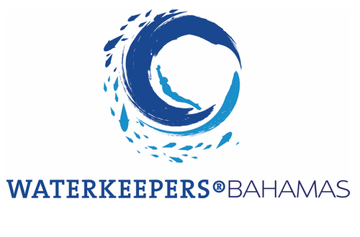 | Waterkeepers Bahamas | Local | https://www.facebook.com/242Waterkeepers/
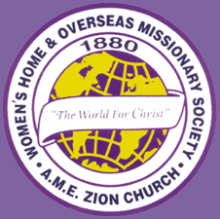 | Women’s Home and Overseas Mission Society | Local | https://whoms.org/?fbclid=IwAR2JaWoqo2xvO7OxUx9mDah1uz_TxAYu4CLwSwR7eXYq8L-n7MV9PENsjG8
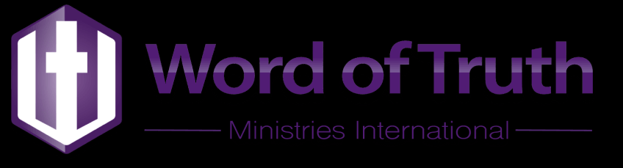 | Word of Truth Ministries International | Local | https://www.wotmibahamas.org/
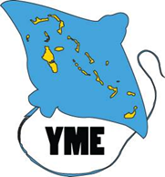 | Young Marine Explorers | Local | https://ymebahamas.org/index.html
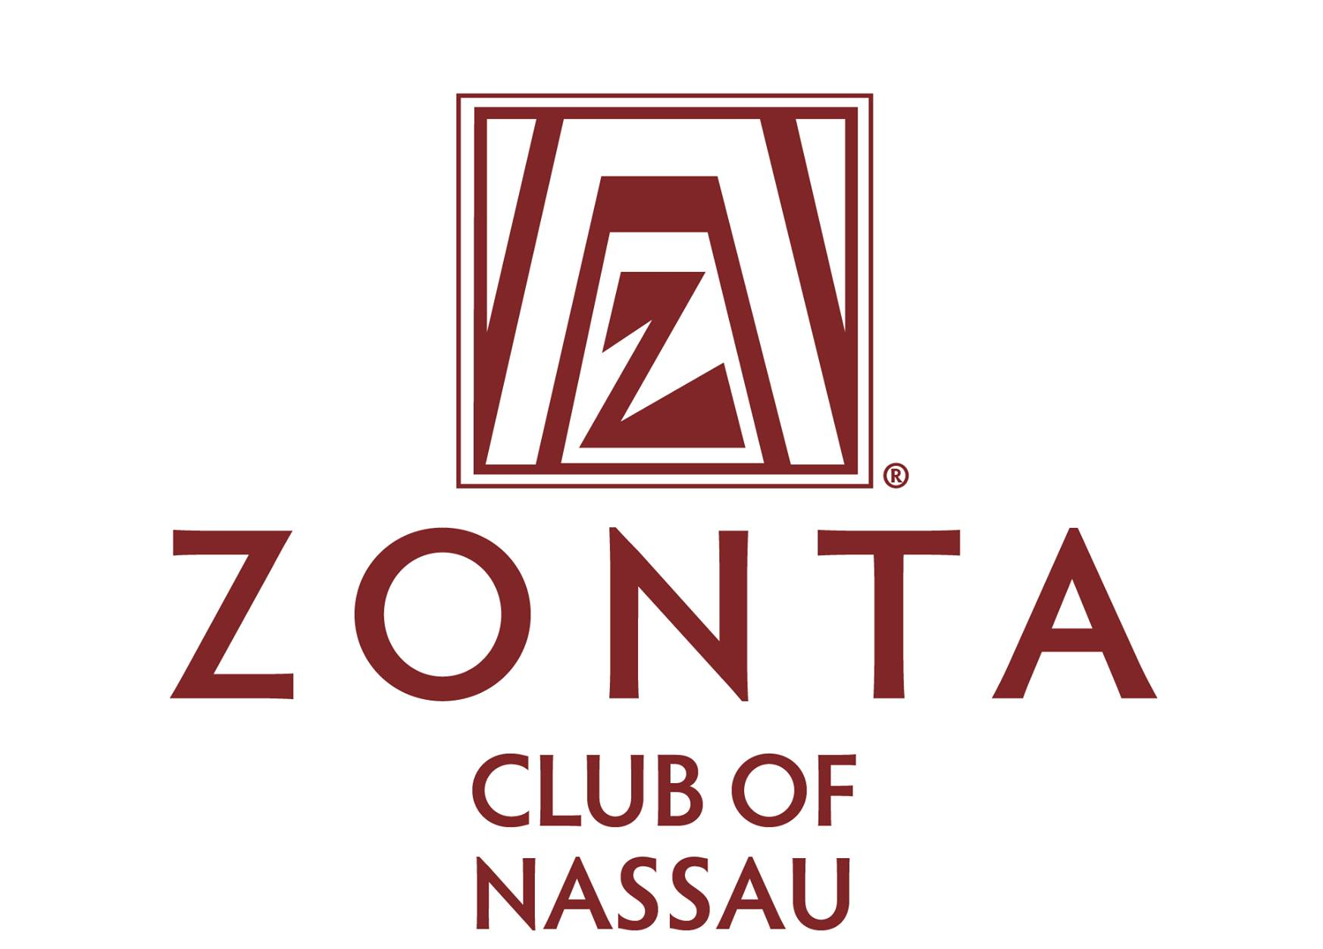 | Zonta Club of Nassau/ New Providence | Local | https://www.facebook.com/Zonta-Club-of-New-Providence-962056327180307/

